**PRACTICAL NO. 10**

**AIM: Session impersonation using Firefox/Chrome and Tamper Data add-on**

**A] Session Impersonation in Chrome**

1. Install EditThisCookie extension in google chrome.

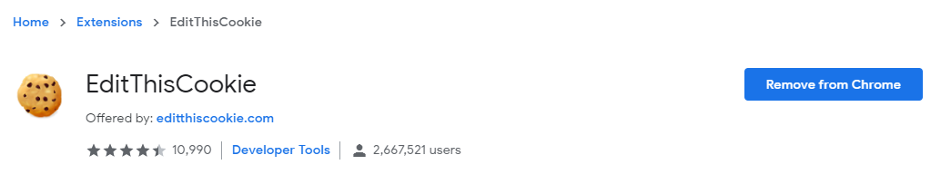

1. Now open any site dashboard like Gmail, FB, Semrush or any with login credentials.

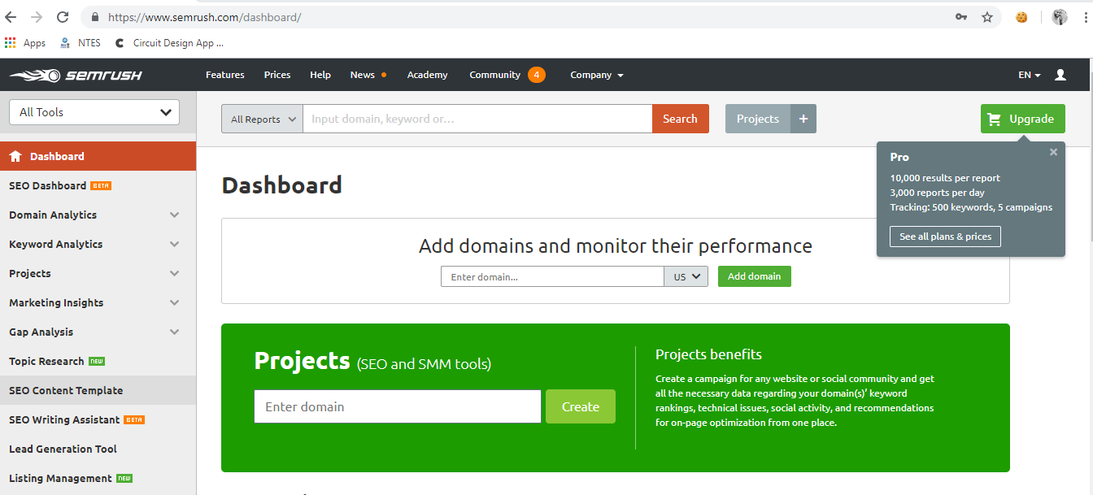

1. Now click on extension and then click on export button to copy the session details.

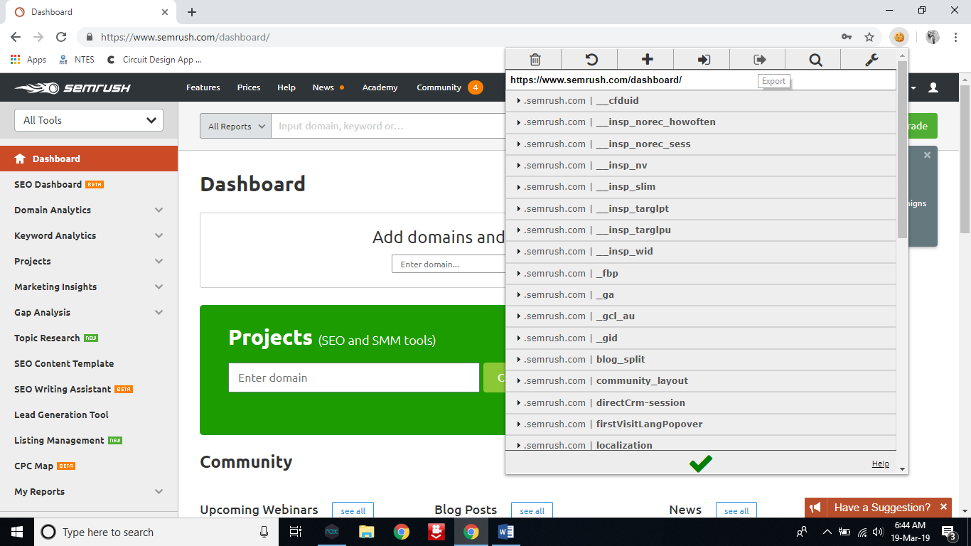

1. Paste this details on a notepad and clos the window tab **without logged out**.
2. Now go to history and delete the history along with cookies also.
3. Now again try to visit the site. This time you won’t be logged in. you have to enter the login details. Now close the tab of site.
4. Now copy the text from notepad which you had copied in step 4. Now open the extension and click on import.

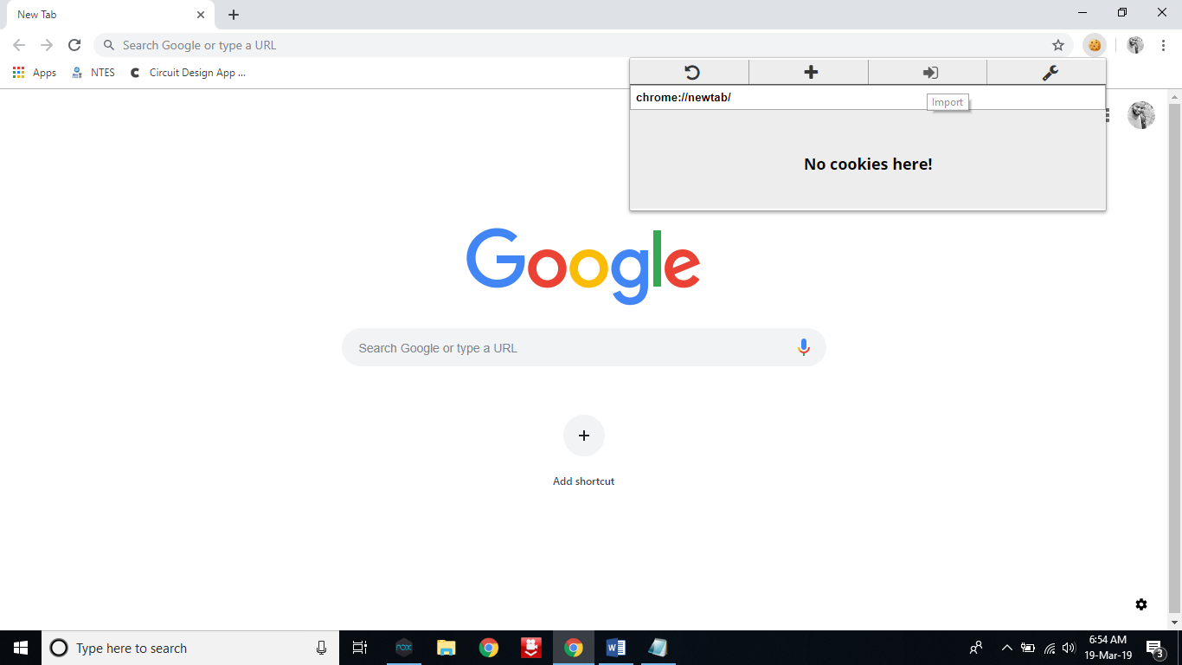

1. Paste the session details in import box and click on green color right mark.

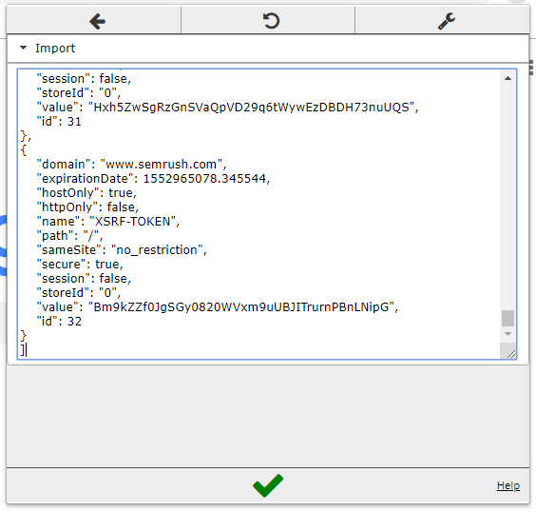

1. Now again try to visit the site. In my case, it is <https://www.semrush.com/dashboard/>. It will automatically open your dashboard without asking for login details.

**STEPS on Firefox**

1. Open FireFox

2. Go to Tools > Addons > Extension

3. Search and install EditThisCookie or Cookie Import/Export or any other Cookie tool

4. Then Click on Cookie extension to get cookie

5. Open a Website and Login and then click on export cookie



Logout from the webpage once the cookie got exported

Paste the cookie in the tool which you have exported and click on green tick



**Tamper DATA add-on**

1. Open FireFox

2. Go to Tools > Addons > Extension

3. Search and install Temper Data

Select a website for tempering data e.g(razorba)



Select any item to but

Then Click to add cart

Then Click on tool for tempering Data



Then start Tempering the data.